Appendix 8: Example: World Cup Baseball 2011 Panamafinal game the Netherlands – Cuba
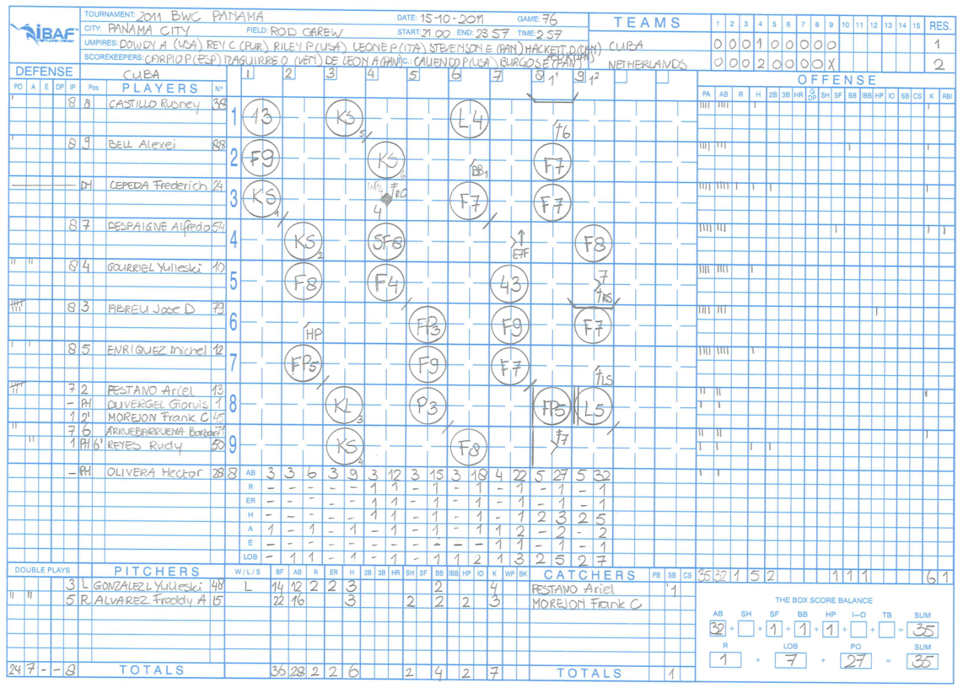
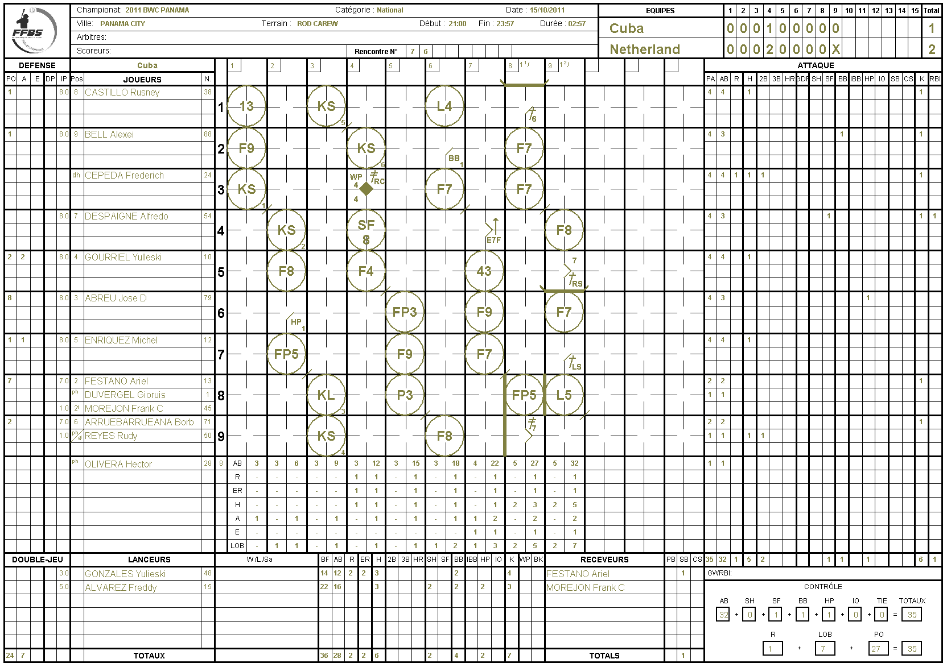

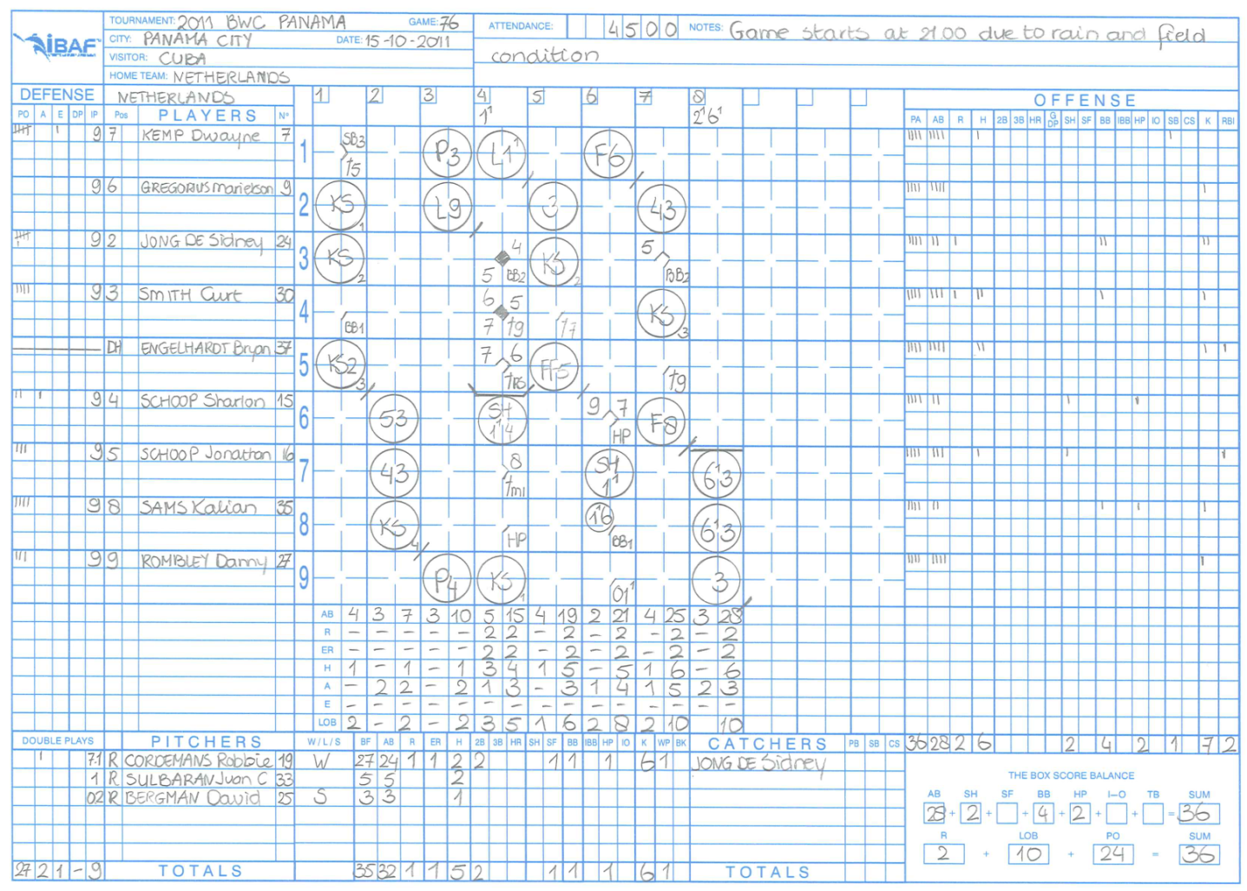

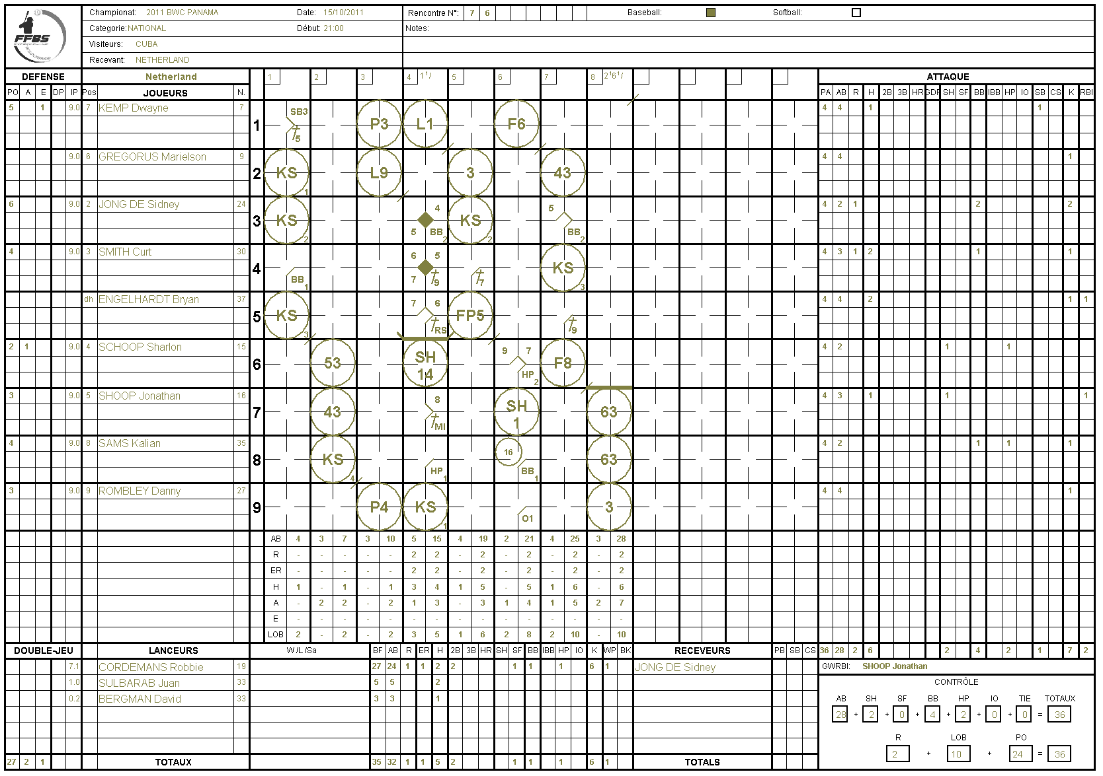

/***********************************************************************************/
/* Automatic parse of game : 76 */
/* Date : mercredi 23 janvier 2019 */
/***********************************************************************************/

/* start of game description */
game "76" {

/* description of the game */
header {
tournament = "2011 BWC PANAMA";
stadium = "ROD CAREW";
place = "PANAMA CITY";
date = "15/10/2011";
startTime = "21:00";
endTime = "23:57";
duration = "02:57";
type = baseball;
category = "National";
scorekeepers = "";
umpires = "";
}

/* Roster of the visitor team */
roster visitor "Cuba" {
player "ABREU Jose D",
player "ALVAREZ Freddy",
player "ARRUEBARRUEANA Borbas",
player "BELL Alexei",
player "CASTILLO Rusney",
player "CEPEDA Frederich",
player "DESPAIGNE Alfredo",
player "DUVERGEL Gioruis",
player "ENRIQUEZ Michel",
player "FESTANO Ariel",
player "GONZALES Yulieski",
player "GOURRIEL Yulleski",
player "MOREJON Frank C",
player "OLIVERA Hector",
player "REYES Rudy"
}

/* Roster of the hometeam team */
roster hometeam "Netherland" {
player "BERGMAN David",
player "CORDEMANS Robbie",
player "ENGELHARDT Bryan",
player "GREGORUS Marielson",
player "JONG DE Sidney",
player "KEMP Dwayne",
player "ROMBLEY Danny",
player "SAMS Kalian",
player "SCHOOP Sharlon",
player "SHOOP Jonathan",
player "SMITH Curt",
player "SULBARAB Juan"
}

/* Game description 76 */
gameEntry {

/* Lineup description for the visitor */
lineup visitor {
/* 01 */ name= "CASTILLO Rusney" defensivePosition = 8 shirtNumber = 38;
/* 02 */ name= "BELL Alexei" defensivePosition = 9 shirtNumber = 88;
/* 03 */ name= "CEPEDA Frederich" defensivePosition = dh shirtNumber = 24;
/* 04 */ name= "DESPAIGNE Alfredo" defensivePosition = 7 shirtNumber = 54;
/* 05 */ name= "GOURRIEL Yulleski" defensivePosition = 4 shirtNumber = 10;
/* 06 */ name= "ABREU Jose D" defensivePosition = 3 shirtNumber = 79;
/* 07 */ name= "ENRIQUEZ Michel" defensivePosition = 5 shirtNumber = 12;
/* 08 */ name= "FESTANO Ariel" defensivePosition = 2 shirtNumber = 13;
/* 09 */ name= "ARRUEBARRUEANA Borbas" defensivePosition = 6 shirtNumber = 71;
/* 10 */ name= "GONZALES Yulieski" defensivePosition = 1 shirtNumber = 48;
}

/* Lineup description for the hometeam */
lineup hometeam {
/* 01 */ name= "KEMP Dwayne" defensivePosition = 7 shirtNumber = 7;
/* 02 */ name= "GREGORUS Marielson" defensivePosition = 6 shirtNumber = 9;
/* 03 */ name= "JONG DE Sidney" defensivePosition = 2 shirtNumber = 24;
/* 04 */ name= "SMITH Curt" defensivePosition = 3 shirtNumber = 30;
/* 05 */ name= "ENGELHARDT Bryan" defensivePosition = dh shirtNumber = 37;
/* 06 */ name= "SCHOOP Sharlon" defensivePosition = 4 shirtNumber = 15;
/* 07 */ name= "SHOOP Jonathan" defensivePosition = 5 shirtNumber = 16;
/* 08 */ name= "SAMS Kalian" defensivePosition = 8 shirtNumber = 35;
/* 09 */ name= "ROMBLEY Danny" defensivePosition = 9 shirtNumber = 27;
/* 10 */ name= "CORDEMANS Robbie" defensivePosition = 1 shirtNumber = 19;
}

/* Inning 1 : visitor */
inning visitor number 1 {
note = "Game starts at 21:00 due to rain field condition";
action { batter ("CASTILLO Rusney") -> 13}
action { batter ("BELL Alexei") -> F9}
action { batter ("CEPEDA Frederich") -> KS}
}

/* Inning 1 : hometeam */
inning hometeam number 1 {
action { batter ("KEMP Dwayne") -> 1B5}
action { batter ("GREGORUS Marielson") -> KS }
action { runner1 ("KEMP Dwayne") -> SB}
action { batter ("JONG DE Sidney") -> KS}
action { batter ("SMITH Curt") -> BB}
action { batter ("ENGELHARDT Bryan") -> KS}
}

/* Inning 2 : visitor */
inning visitor number 2 {
action { batter ("DESPAIGNE Alfredo") -> KS }
action { batter ("GOURRIEL Yulleski") -> F8 }
action { batter ("ABREU Jose D") -> HP }
action { batter ("ENRIQUEZ Michel") -> FP5 }
}

/* Inning 2 : hometeam */
inning hometeam number 2 {
action { batter ("SCHOOP Sharlon") -> 53}
action { batter ("SHOOP Jonathan") -> 43}
action { batter ("SAMS Kalian") -> KS}
}

/* Inning 3 : visitor */
inning visitor number 3 {
action { batter ("FESTANO Ariel") -> KL}
action { batter ("ARRUEBARRUEANA Borbas") -> KS}
action { batter ("CASTILLO Rusney") -> KS}
}

/* Inning 3 : hometeam */
inning hometeam number 3 {
action { batter ("ROMBLEY Danny") -> P4}
action { batter ("KEMP Dwayne") -> P3}
action { batter ("GREGORUS Marielson") -> L9}
}

/* Inning 4 : visitor */
inning visitor number 4 {
action { batter ("BELL Alexei") -> KS}
action { batter ("CEPEDA Frederich") -> 2BRC}
action { runner2 ("CEPEDA Frederich") -> WP}
action { batter ("DESPAIGNE Alfredo") -> SF8 , runner3 ("CEPEDA Frederich") -> + earned}
action { batter ("GOURRIEL Yulleski") -> F4 }
}

/* Inning 4 : hometeam */
inning hometeam number 4 {
action { batter ("JONG DE Sidney") -> BB}
action { batter ("SMITH Curt") -> 1B9 , runner1 ("JONG DE Sidney") -> + }
action { batter ("ENGELHARDT Bryan") -> 1BRS, runner1 ("SMITH Curt") -> +,runner2 ("JONG DE Sidney") -> ++ earned}
substitution visitor {
player 1 replaceBy "ALVAREZ Freddy" shirtNumber = 15 at 1
}
action { batter ("SCHOOP Sharlon") -> SH14, runner1 ("ENGELHARDT Bryan") -> + ,runner2 ("SMITH Curt") -> +}
action { batter ("SHOOP Jonathan") -> 1BMI, runner2 ("ENGELHARDT Bryan") -> +,runner3 ("SMITH Curt") -> + earned}
action { batter ("SAMS Kalian") -> HP, runner1 ("SHOOP Jonathan") -> + }
action { batter ("ROMBLEY Danny") -> KS}
action { batter ("KEMP Dwayne") -> L1}
}

/* Inning 5 : visitor */
inning visitor number 5 {
action { batter ("ABREU Jose D") -> FP3 }
action { batter ("ENRIQUEZ Michel") -> F9}
action { batter ("FESTANO Ariel") -> P3 }
}

/* Inning 5 : hometeam */
inning hometeam number 5 {
action { batter ("GREGORUS Marielson") -> 3}
action { batter ("JONG DE Sidney") -> KS}
action { batter ("SMITH Curt") -> 1B7}
action { batter ("ENGELHARDT Bryan") -> FP5}
}

/* Inning 6 : visitor */
inning visitor number 6 {
action { batter ("ARRUEBARRUEANA Borbas") -> F8}
action { batter ("CASTILLO Rusney") -> L4}
action { batter ("BELL Alexei") -> BB}
action { batter ("CEPEDA Frederich") -> F7}
}

/* Inning 6 : hometeam */
inning hometeam number 6 {
action { batter ("SCHOOP Sharlon") -> HP}
action { batter ("SHOOP Jonathan") -> SH1, runner1 ("SCHOOP Sharlon") -> +}
action { batter ("SAMS Kalian") -> BB }
action { batter ("ROMBLEY Danny") -> O1, runner1 ("SAMS Kalian") -> 16 ,runner2 ("SCHOOP Sharlon") -> +}
action { batter ("KEMP Dwayne") -> F6}
}

/* Inning 7 : visitor */
inning visitor number 7 {
action { batter ("DESPAIGNE Alfredo") -> E7F+}
action { batter ("GOURRIEL Yulleski") -> 43}
action { batter ("ABREU Jose D") -> F9}
action { batter ("ENRIQUEZ Michel") -> F7}
}

/* Inning 7 : hometeam */
inning hometeam number 7 {
action { batter ("GREGORUS Marielson") -> 43}
action { batter ("JONG DE Sidney") -> BB}
action { batter ("SMITH Curt") -> KS}
action { batter ("ENGELHARDT Bryan") -> 1B9, runner1 ("JONG DE Sidney") -> ++}
action { batter ("SCHOOP Sharlon") -> F8}
substitution visitor {
player 2 replaceBy "DUVERGEL Gioruis" shirtNumber=1 at ph8,
player 6 replaceBy "REYES Rudy" shirtNumber=50 at ph9
}
}

/* Inning 8 : visitor */
inning visitor number 8 {
action { batter ("DUVERGEL Gioruis") -> FP5}
action { batter ("REYES Rudy") -> 2B7}
substitution hometeam {
player 1 replaceBy "SULBARAB Juan" shirtNumber=33 at 1
}
action { batter ("CASTILLO Rusney") -> 1B6}
action { batter ("BELL Alexei") -> F7}
action { batter ("CEPEDA Frederich") -> F7}
}

/* Inning 8 : hometeam */
inning hometeam number 8 {
substitution visitor {
player ph8 replaceBy "MOREJON Frank C" shirtNumber=45 at 2,
player ph9 moveTo 6
}
action { batter ("SHOOP Jonathan") -> 63}
action { batter ("SAMS Kalian") -> 63}
action { batter ("ROMBLEY Danny") -> 3}
}

/* Inning 9 : visitor */
inning visitor number 9 {
substitution visitor {
player 2 replaceBy "OLIVERA Hector" shirtNumber=28 at ph8
}

action { batter ("DESPAIGNE Alfredo") -> F8}
action { batter ("GOURRIEL Yulleski") -> 1BRS}
substitution hometeam {
player 1 replaceBy "BERGMAN David" shirtNumber=33 at 1
}
action { batter ("ABREU Jose D") -> F7}
action { batter ("ENRIQUEZ Michel") -> 1BLS, runner1 ("GOURRIEL Yulleski") -> +}
action { batter ("DUVERGEL Gioruis") -> L5 }
}
}
}

